https://eepurl.com/iB2GnQ

**[Subscribe](http://eepurl.com/iByvrM)**

**[Past Issues](https://us21.campaign-archive.com/home/?u=dc4d77e32c626cedfa96eca9e&id=5f69bf60dc)**

V [iew this email in your browser](https://us21.campaign-archive.com/?e=%5BUNIQID%5D&u=dc4d77e32c626cedfa96eca9e&id=c9b4c52d11)

# NK DAIRY PRODUCTS

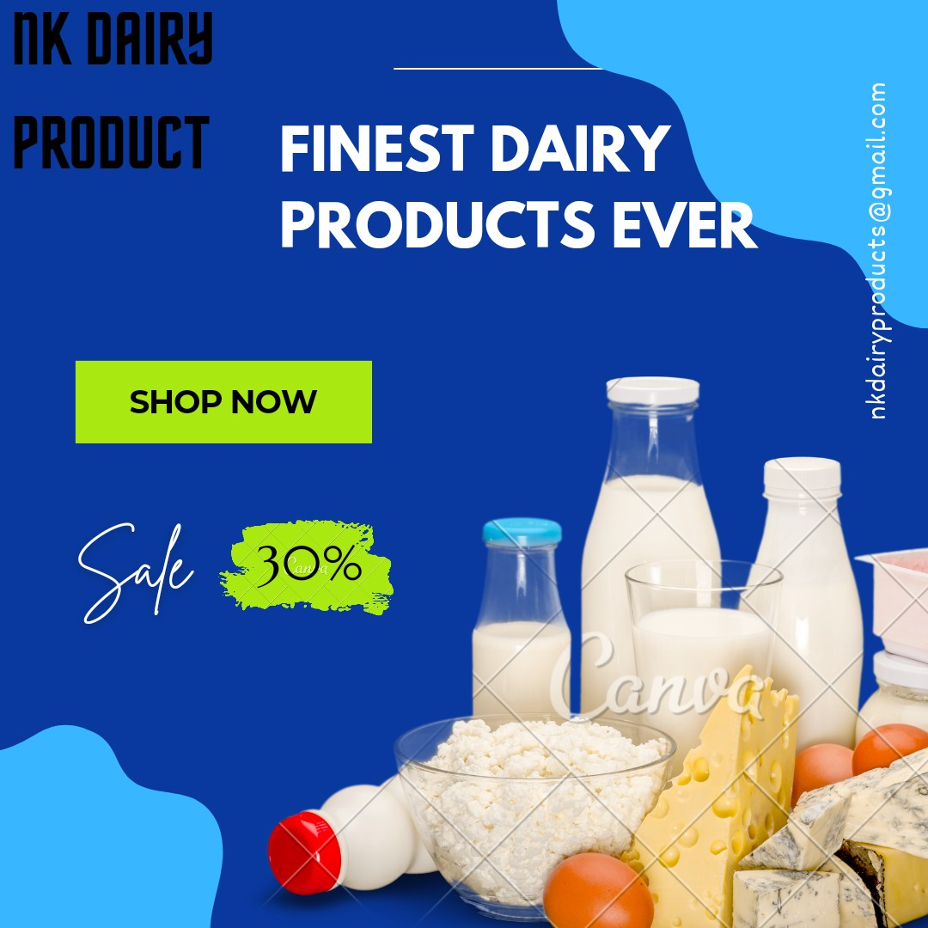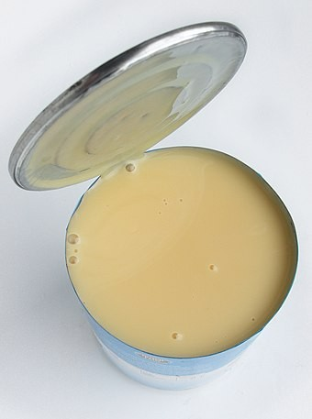

NK Dairy products

Dairy products derived from milk, which has been an important source of nutrition for people for thousands of years. These include products made from milk, such as

cheese, yogurt, keﬁr, ice cream and butter.

[nkdairypr](mailto:nkdairyproducts@gmail.com)[oducts@gmail.com](mailto:oducts@gmail.com)